Institutional Ethics Committee for Human Research
Application for Ethical Review of Research Protocol

To Date:

The Member Secretary
Institutional Ethics Committee
Institute of Tran-disciplinary Health Sciences and Technology
Bengaluru

Full name of Principal Investigator: | Dr. Ashwini Godbole
Designation: | Associate Professor
Complete Postal Address: | Institute of Tran-disciplinary Health Sciences and Technology, Bengaluru
Tel. No: Office and Fax. No.
E-mail: | Ashwini.g@tdu.edu.in

Site of study: | IAIM hospital
Title of Project: | Analysis of hospital based ayurvedic clinical practice to gain real world data knowledge (retrospective study of anonymized patient level data at IAIM hospital)
Sponsor Name and address: | Institute of Tran-disciplinary Health Sciences and Technology, Bengaluru

Sl. No. | Name | Signature
Principal Investigator
Co-Investigator
Co-Investigator
Type of study: Local / National / International
Type of Trial: Multi center / Single center

Name & Signature of Principal Investigator Date:

{Application must be submitted along with the study protocol, consent form (English and local language), Approval letters (if any, other scientific committee or ethics committee) and other essential documents for the review}.
PROTOCOL COVER PAGE

PROTOCOL NAME: Analysis of hospital based ayurvedic clinical practice to gain real world data knowledge (retrospective study of anonymized patient level data at IAIM hospital)

PROTOCOL NUMBER:

PROTOCOL VERSION & DATE: V1.1 and 15th March 2020

GENERAL INFORMATION

Name and address of the sponsor of the study?
Dr. Ashwini Godbole
Dr. Girish Tillu
Dr. Ashwini Mathur
Vinay Mahajan

Name and address of the person authorized to sign the protocol and amendments
Vinay Mahajan

Name and address of study monitor: Dr. Girish Tillu

Name, title, address and telephone number(s) of the medical expert for the trial
Dr Poornima and Dr Prasan Shankar fill the details

Name and title of the investigator(s) and sub-investigators responsible for the trial with address and phone number(s)

Name and addresses of the clinical laboratories and/or other institutions involved in the trial
IAIM Hospital, Institute of Tran-disciplinary Health Sciences and Technology, Bengaluru

Table of Contents

1 Backgr

.2 Preclinical Data 1
1.3 Risk/Benefits 1
1.4 Dose Rational 1
1.5 Trial Conduct 1
1.6 Population 1
1.7 Literature 1
2 Trial Objectives 1
3 Trial Design 2
3.1 Primary Study Endpoints/Secondary Endpoints 2
3.2 Study Design/Type 2
3.3 Randomization 2
3.4 Maintenance 2
3.5 Trial Treatment 2
3.6 Duration 2
3.7 Discontinuation 2
3.8 Product Accountability 2
3.9 Data Identification 3
4 Selection and Withdrawal of Subjects 3
4.1 Inclusion Criteria 3
4.2 Exclusion Criteria 3
4.3 Subject Withdrawal 3
4.4 Treatment of Subjects 3
4.5 Medication 3
4.6 Monitoring for subject compliance 3
5 Assessment of Efficacy 4
5.1 Efficacy Parameters 4
5.2 Method and Timing 4
6 Assessment of Safety 4
6.1 Safety Parameters 4
6.2 Method and Timing 4
6.3 Adverse Event Reporting 4
6.4 Definitions 4
6.5 Adverse Event Follow-up 4
7 Statistical Plan 5
7.1 Statistical Methods 5
7.2 Subject Population(s) for Analysis 5
7.3 Significance 5
7.4 Termination Criteria 5
7.5 Accountability Procedure 5
7.6 Deviation Reporting 5
8 Direct Access to Source Data/Documentation 5
9 Quality Control and Quality Assurance 5
10 Ethical Considerations 6
11 Data Handling and Record Keeping 6
12 Finance and Insurance 6
13 Publication Plan 6
14 Supplements 6

List of Abbreviations

FDA: Food and Drug Administration USA
EMA: European Medical Agency
IAIM: Institute of Ayurveda and Integrative Medicine
NLP: Natual Language Processing
ICH: The International Council for Harmonisation of Technical Requirements for Pharmaceuticals for Human Use
SQL: Structured Query Language

1 Background:

Real world data is the information relating to patient health status and/or the delivery of health care routinely collected from a variety of sources. This data holds potential to allow us to better design and conduct clinical trials and studies in the health care setting; to answer questions previously thought infeasible. In addition, with the development of sophisticated, new analytical capabilities, we are able to analyze these data and apply the results much better to support standardized medical practice/methods, medical product development and approval.

Ayurveda has been practiced over many centuries in India. It will be safe to assume that the conceptual developments in ayurvedic knowledge base have taken place through every day observations and basic laws of nature. These fundamentals have been adjusted to the relevant times as per the passage of time, which is quite evident from vast literary history of Ayurveda, which covers subjects like pharmacology, principle of diagnosis and treatment for all branches of medicine and surgery, philosophical framework and logic, pharmacy and numerous pharmacopeias. Traditional texts enumerate more than described for each disease condition.

Generating credible evidence for such a large pool only through modern experimental means such as trials is very challenging. Methodologists are challenging current hierarchical evidence model and the circular model comprising observational research methods are proposed for CAM research. Ayurveda like any other system of medicine, is practiced more in clinics than in clinical research setting, where there are no artificial restrictions on usage of medicines, duration of treatment or type of patients to treat, which is next to impossible in a protocol driven clinical trial setting.

The TDU Ayurvedic hospital database is a pioneer in capturing electronic health or medical records (EHR, EMR) since year 2011. It contains data for >51,000 patients, >1,50,000 visits, > 900 variations of disease types, >3,000 variations of medical procedures. The EMRs contain all of the above-mentioned data points plus a few more for the ayurvedic parameters.

This study will be one attempt in plugging the gap of missing empirical evidence, systematic analysis of observational clinical data. It is focused on IAIM clinical data for study of efficacy and safety trends. In our study of modern regulatory framework, we recognized similarity between concepts written by Charaka and ICH guidelines. This will form the philosophical basis for the research question. Modern statistical programming approaches, data visualization techniques, deep learning algorithms based on Natural Language Processing (NLP) will be used. We believe that this is a novel approach utilized for the first time with the ayurvedic data. These exploratory approaches will generate empirical results on existing version of IAIM data. Subsequently these will provide a frame work to researchers to identify hidden patterns.

Aim: To evaluate patterns of data on symptomology, examinations, diagnosis, treatment and outcomes of Ayurveda based management at IAIM hospital for selected conditions to generate real world evidence by using visual analytics, deep learning techniques.

Objective of the study: to explore clinical documentation of cases of musculoskeletal, and the outcomes of Ayurveda management on selected disease conditions like musculoskeletal, metabolic and neurological conditions

Investigational Agent
The study is based on the already treated patients at IAIM hospital over the years. All the relevant prescribed treatments available in the database will be utilized for the analysis purpose.

Preclinical Data
Not applicable, the study will be carried out on the existing data available in the IAIM hospital database.

Risk/Benefits
Benefits: the existing patient data will be used retrospectively. The planned study will provide the following insights:
- What kind of data has been collected so far for each patient visit?
- What part of data is related to the every day to day operations.
- What part of the data is related to the patient background characteristics, disease conditions, prescribed medicines?
- What are the strengths of the collected data and what are the areas of improvement going forward.
- What kinds of diseases are getting treated more frequently?
- What kinds of treatments are prescribed for what kinds of diseases?
This analysis would add to the evidence base of ayurvedic treatment principles.

Risks:
- The source database for data collection is not designed with the data analysis point of view hence extracting data in a desirable format is a challenge
- The existing database contains sensitive information related to individual patients. All the efforts will be made to protect sensitive information like
  - Name of patient,
  - Full address,
  - Phone numbers,
  - Socio economic status, etc.
This information will not be extracted from source data in order to maintain confidentiality and the patient cannot be traced back and contacted.

Dose Rationale
Not applicable, the study will be carried out on the existing data available in the IAIM hospital database.

Trial Conduct
Not applicable, the study will be carried out on the existing data available in the IAIM hospital database.

Population
Source data for patients having reported at least one disease in the following area will be used:
- Metabolic diseases,

- Rheumatic and Musculoskeletal disease, and
- Neurological cases like sciatica, stroke, neuropathy, etc.

.
ospital database,
- Ayurvedic reference material,
- US FDA website, EMA website,
- References for Real World Evidence,
- Statistical methodological reference material,
- R, Tableau, SQL, Python, Java, etc. software reference material,
- References to Deep learning algorithms

Trial Objectives
Real World Evidence methods, epidemiological research methods like quantitative, qualitative and mixed methods research would be employed to explore the available data. In qualitative health research, observational methods provide direct access to what people do, as well as to what they say and think. These generate an emerging understanding about research questions with two main objectives:
- Preliminary analysis leads to the identification of issues where data need to be further enriched;
- It informs the sampling process, in the sense that researchers are aware of the point in the data collection in which no new categories/themes emerge – data saturation -, signaling that data collection is complete.

Studies of causation, prognosis, and clinical prediction will be carried out according to the quality of preceding evidence, using the optimal study design.

This proposed analysis, due to scale and size of the data, with no artificial limitations of inclusion and exclusion criteria should provide real world evidence view or the epidemiological view for the stated period (from the beginning of hospital in 2011 to October 2017). This will provide additional understanding about ayurvedic data that may be inaccessible using quantitative methods. Basic understanding of the demographic, background history, visit pattern, treatments prescribed at such a large scale should help in building empirical evidence.

Trial Design
The scientific integrity of the trial and the credibility of the data from the trial depend substantially on the trial design. A description of the trial design includes:

The database captures complete picture of patient experience in day to day clinical practice. It captures modern medical parameters obtained through various blood tests, scans, ECGs, etc. as well as it captures Ayurvedic parameters in carefully designed Case Report Forms. The source data is secured in a controlled environment with SQL database at the back end. This data is accessed using SQL queries and then using R programming language for necessary calculations. Summarization and tabulation are carried out using R libraries; visuals are built using tableau software for a very easy to use end user experience. The following steps were followed to convert an individual observation to a meaningful table or a visual (References in supplementary material, Fig 1, 2, 3, and 4). The source data is captured in multiple data tables or views, and these need to be combined or aggregated into meaningful data tables for further processing. To get to a consolidated Data version of 25 variables, 15 different data tables had to be processed.

R is a programming language and free software environment for statistical computing and graphics that is supported by the R Foundation for Statistical Computing. The R language is widely used among statisticians and data miners for developing statistical software and data analysis.

Tableau (French for “little table” literally, also used to mean “picture”; pl. tableaux or, rarely, tableaus) is a software providing visual query language interface to convert large amounts of data into beautiful interactive graphical displays.

Both these are freeware software or open source, hence there is no additional financial burden on researchers to procure the best in class analytical capabilities.
Use R program to generate tabular or graphical analysis
Use R program to create analysis data tables
Use source tables from the SQL server
Use SQL queries to combine necessary tables
Use Tableau to generate interactive visual analysis
Fig 1:

- Login on the SQL server using the credentials
- Use the IAIM schema and access the following tables to generate base table with Demographics information, Patient Visit information and prescribed treatments
  - STATE_MASTER
  - COUNTRY_MASTER
  - CITY
  - STATE
  - PATIENT_DETAILS
  - PATIENT_REGISTRATION
  - MRD_DIAGNOSIS
  - PATIENT_PRESCRIPTION
  - PATIENT_MEDICINE_PRESCRIPTIONS
  - IP_PRESCRIPTION
  - SERVICES_PRESCRIBED
  - SERVICES
  - MEDICINE_SALES_VIEW
- There are many CRF pages built to collect relevant Ayurvedic data, measurement data, Hospital visit data, food / exercise advice, etc. This data is present in the following tables:
  - PATIENT_SECTION_DETAILS
  - PATIENT_SECTION_VALUES
  - SECTION_MASTER
  - SECTION_FIELD_OPTIONS
  - SECTION_FIELD_DESC
  - PATIENT_CONSULTATION_FIELD_VALUES
- The datasets created in steps 2 and 3 are further processed using R programming language and the analysis ready datasets are created

Fig 2: SQL code to extract data from the SQL database
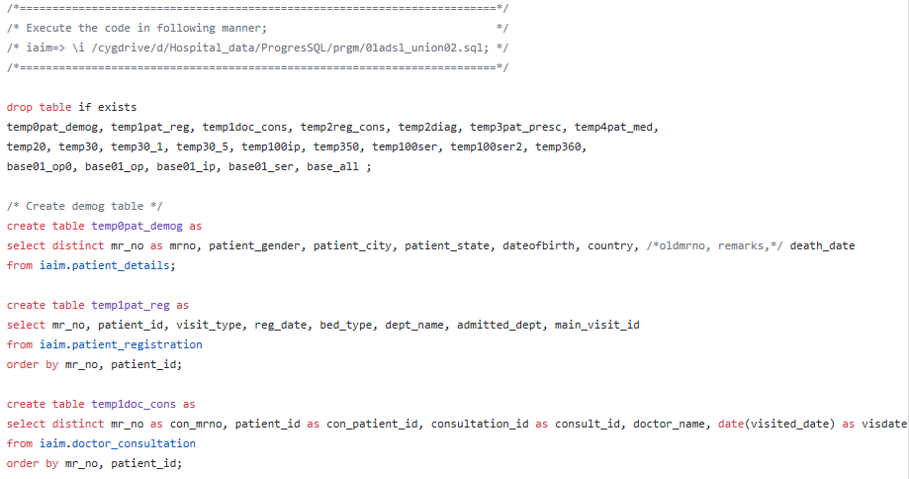
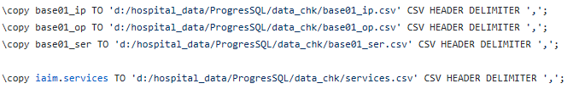

Fig 3: R code, use the input files created using SQL queries
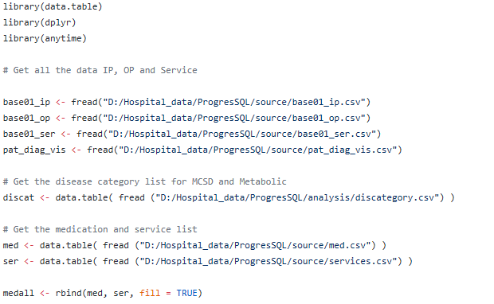
...
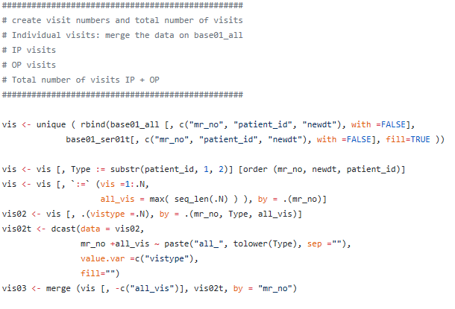

Fig 4: One of the datasets with key variables
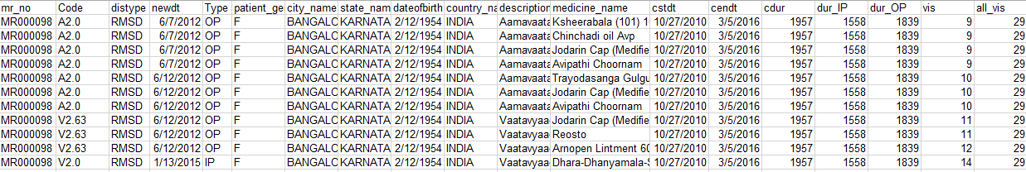

The snapshot shows following variables:
- patient ID,
- Disease code,
- Disease type,
- Date of visit,
- visit type (IP, OP),
- gender,
- city,
- state,
- date of birth,
- Country,
- Description of disease,
- Medicine name,
- Start date,
- End date,
- Total duration,
- In Patient duration,
- Outpatient duration,
- Visit number,
- Total number of visits, etc.

Primary Study Endpoints/Secondary Endpoints
Various visual analytics providing insights into (1) Operational data, (2) Clinical data, (3) every day clinical practice, (4) new hypothesis generation, (5) deep learning using Natural Language Processing (NLP) approaches

Study Design/Type
Real World evidence approach employed to the existing data. Ayurvedic hospital in TDU is operational since year 2011 and hosts one of the largest electronic databases of Ayurvedic medical practice. The hospital database contains clinical data for more than 51000 patients since 2011 to October 2017. The Ayurvedic disease classification dictionary (ACD) is used to code the diseases [Dictionary developed at the University, and CDAC, Pune]. There are approximately 170,000 visits recorded, covering more than 900 unique diseases, more than 3000 medicinal procedures*, in-patient as well as out-patient visits.

The existing patient level data will be utilized as “Source data”. Source data will be accessed from the existing database. Source data reported from day 1 of hospital till October 2017 will be used. This source data is further processed to add new variables for analysis purpose and new datasets called as “analysis data” are created

Randomization
Not applicable, the study will be carried out on the existing data available in the IAIM hospital database.

Maintenance
Not applicable, the study will be carried out on the existing data available in the IAIM hospital database.

Trial Treatment
Not applicable, the study will be carried out on the existing data available in the IAIM hospital database.

Duration
Not applicable, the study will be carried out on the existing data available in the IAIM hospital database.

Discontinuation
Not applicable, the study will be carried out on the existing data available in the IAIM hospital database.

Product Accountability
Not applicable, the study will be carried out on the existing data available in the IAIM hospital database.

Data Identification
All the data available in the source database which will be analyzed. Sensitive information related to Patient identification will not be extracted for analysis from source data. Details on how much data will used and what will be excluded is explained in the analysis section below. Selection and Withdrawal of Subjects

Inclusion Criteria
Patients having the following diseases reported at least once in the hospital database
- Metabolic diseases,
- Rheumatic and Musculoskeletal diseases,
- Neurological diseases,
- Cancer

Exclusion Criteria
Patients who do not have any of the above reported diseases in the hospital database.

Subject Withdrawal
Not applicable, the study will be carried out on the existing data available in the IAIM hospital database.

Treatment of Subjects
Not applicable, the study will be carried out on the existing data available in the IAIM hospital database.

Medication
Not applicable, the study will be carried out on the existing data available in the IAIM hospital database.

Monitoring for subject compliance
Not applicable, the study will be carried out on the existing data available in the IAIM hospital database.

Assessment of Efficacy
Not applicable, the study will be carried out on the existing data available in the IAIM hospital database.

Efficacy Parameters
Not applicable, the study will be carried out on the existing data available in the IAIM hospital database.

Method and Timing
Not applicable, the study will be carried out on the existing data available in the IAIM hospital database.

Assessment of Safety
Not applicable, the study will be carried out on the existing data available in the IAIM hospital database.

Safety Parameters
Not applicable, the study will be carried out on the existing data available in the IAIM hospital database.

Method and Timing
Not applicable, the study will be carried out on the existing data available in the IAIM hospital database.

Adverse Event Reporting
Not applicable, the study will be carried out on the existing data available in the IAIM hospital database.

Definitions
Not applicable, the study will be carried out on the existing data available in the IAIM hospital database.

Adverse Event Follow-up
Not applicable, the study will be carried out on the existing data available in the IAIM hospital database.

Statistical Plan
Exploration of data will be carried out to understand various components of the data. This will involve the following aspects:
- Inspection of data collected over the years
- Understand and describe the data present in Case Report Forms,
- Understand and describe the operational part of the data
- Understand and describe the clinical part of the data

Statistical Methods
- Statistical methods to be employed:
  - Graphical methods to display many data in a concise form, trellis graphics, heat maps, etc.
  - Pattern or trend analysis: to understand the underlying clusters within the data
  - Decision theory analysis: to understand how the treatment gets assigned and what calculations, algorithms go through a doctor’s mind
  - Multivariate analysis: to model the data and gain more insights
- Innovative and emerging tools and techniques from Omics / bioinformatics etc.
- Deep learning algorithms

Subject Population(s) for Analysis
As explained in section 3.10. These sets of patients will be used for the analysis. Any patient having at least a single visit will be included in the analysis.

Significance
Exploratory analysis will be carried out, hence there is no significance testing done.

Termination Criteria
Not applicable, the study will be carried out on the existing data available in the IAIM hospital database.

Accountability Procedure
Not applicable, the study will be carried out on the existing data available in the IAIM hospital database.

Deviation Reporting
Not applicable, the study will be carried out on the existing data available in the IAIM hospital database.

Direct Access to Source Data/Documentation
Hospital database will be accessed to extract the current data using “read-only permission”. The source data will not modified.

Quality Control and Quality Assurance
All the analysis methods will be documented stepwise. These will be reviewed by guides independently. Manual checks for data consistency will be done by having regular meetings for review of the data analysis. Cross comparison of a few cases with the Case Sheets will be carried out for data plausibility.

Ethical Considerations
The existing data will be used to understand the clinical insights.
- Sensitive information related to the treating doctors will not be extracted for analysis purpose.
- Sensitive information related to the patients will not be extracted for analysis purpose.
- Any data analysis with very few patients (e.g. less than 5) will not be undertaken to additionally protect potential un-anonymization of patients.

Data Handling and Record Keeping
Not applicable, the study will be carried out on the existing data available in the IAIM hospital database.

Finance and Insurance
Not applicable, the study will be carried out on the existing data available in the IAIM hospital database.

Publication Plan
The data contents, analysis and any publications made to the external world will be owned by TDU.

Supplements
The documents and programs generating the analysis will be submitted as appropriate.

Following documents must be submitted:
1. Application form (scanned copy/original can be submitted while applying for review; original must be submitted to receive approval letter)
2. Study protocol
3. Data collection tools
4. Consent form (English and local language)
5. CV of investigators
6. Any other relevant documents

